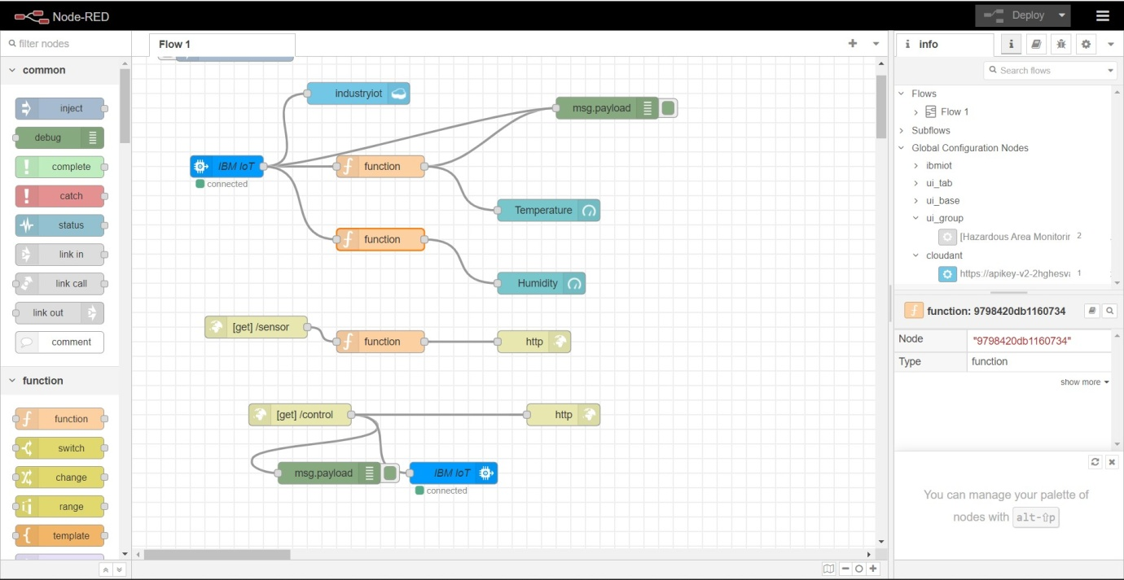**Use Dashboard Nodes For Creating UI(Web App)**

|  |  |
| --- | --- |
| Date | 17 November 2022 |
| Team Id | PNT2022TMID46546 |
| Title | Hazardous Area Monitoring for Industrial Plant using IoT |

**Node red flow**

**Dashboard configuration**

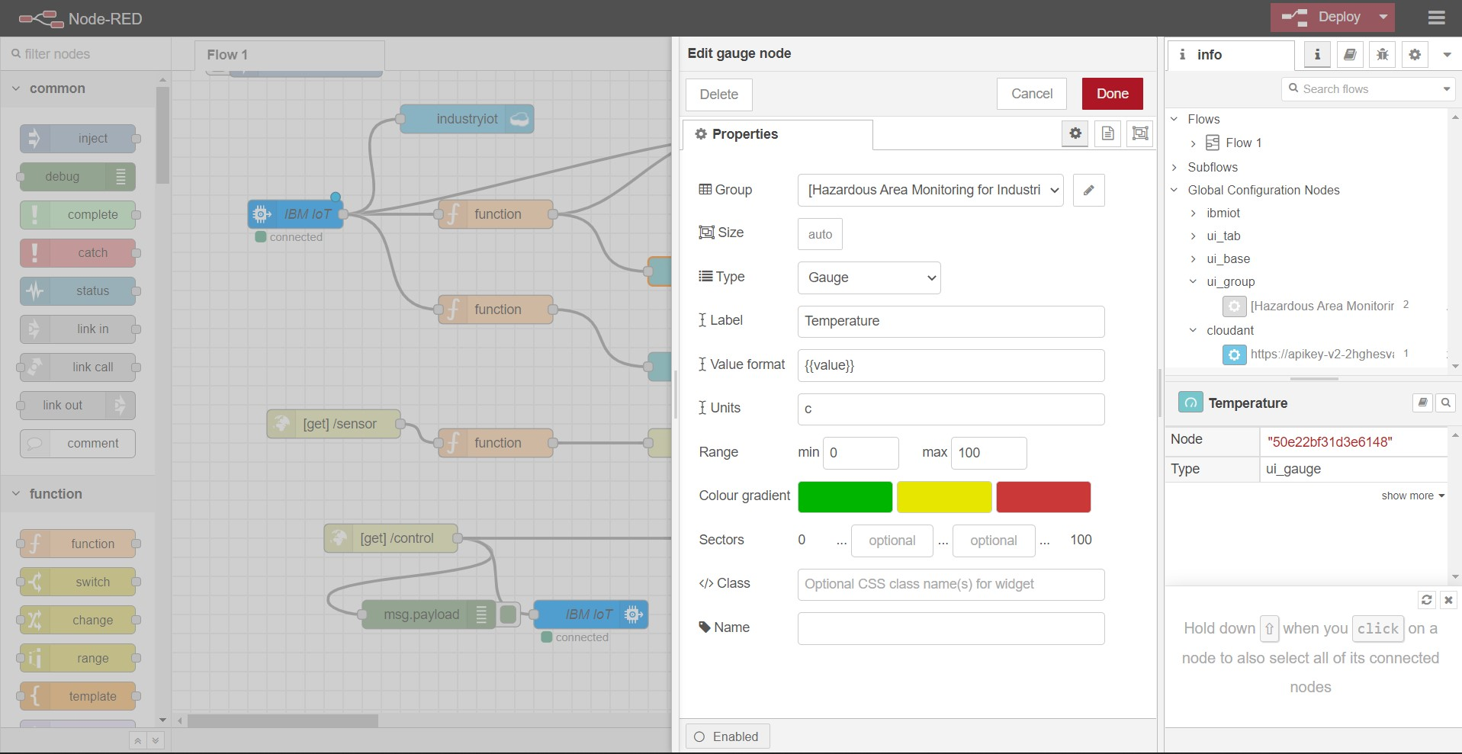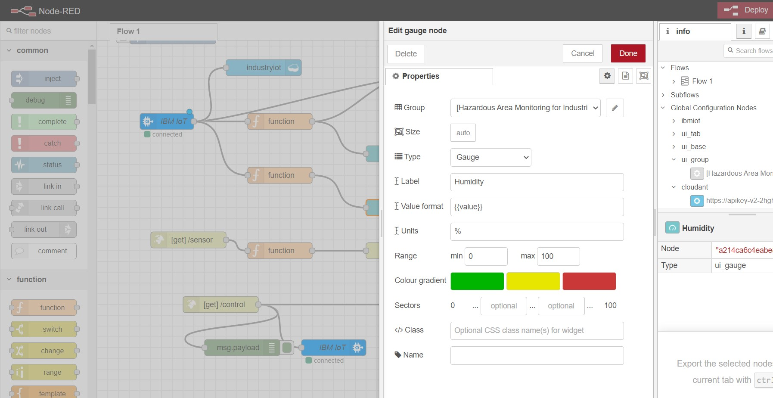

**Final Output - Dashboard**

